UNIGLOBE COLLEGE
(Affiliated to Pokhara University)
New Baneswor, Kathmandu



Third Semester Project Report
On
“Swift Serve – Canteen Pre-order system”
(PRJ181)

A Fourth Semester Project Report
Submitted in the partial fulfillment of the requirements for the degree of Bachelor of Computer System and Information Technology awarded by Pokhara University

Under the supervision of
Annu Khanna Nakarmi
Lecturer/Supervisor

Submitted By:

Submitted To:
UNIGLOBE COLLEGE
Department of Computer Science and Information Technology
New Baneswor, Kathmandu, Nepal
May, 2026

“Swift Serve – Canteen Pre-order system”
(PRJ181)

A fourth semester project report submitted in partial fulfillment of the requirements for the degree of Bachelor of Computer System and Information Technology awarded by Pokhara University

Submitted By

Submitted To
UNIGLOBE COLLEGE
Department of Computer Science and Information Technology
New Baneshwor, Kathmandu, Nepal
May 2026

Abstract

The Canteen Pre-order System is a web application built to streamline and revolutionize the food ordering procedure at a college canteen, making it easier for students to order food online without standing in line, wasting precious time. This application will allow students to create a user account, log in, choose from the menu options, browse specials of the day, check which products are sold out, and order instantly using a one-click option without having to go through the hassle of filling a shopping cart. After placing the order, users will be able to see its current status, which includes Pending, Preparing, Ready for Pick-Up, and Payment Made and Order Completed. Besides, students can track their past orders and refer back to them when needed. From the admin's perspective, the system will offer a dashboard where canteen employees can manage the menu items, add new food products, edit their descriptions, remove items that are no longer offered, update item availability, mark some products as sold out, and easily handle incoming orders. The project uses a well-organized relational database, including tables for students, admins, menu items, orders, and completed orders.

TABLE OF CONTENTS

Abstract 2
TABLE OF CONTENTS 1
LIST OF FIGURES 3
ABBREVIATIONS 4
CHAPTER 1: INTRODUCTION 1
1.1 Background 1
1.2 Problem Statement 2
1.3 Objectives of the Project 2
1.4 Scope of the Project 2
1.5 Limitations of the Project 2
1.6 Significance of the Study 2
CHAPTER 2: LITERATURE REVIEW 3
CHAPTER 3: SYSTEM ANALYSIS AND DESIGN 8
3.1 Project Management Strategy and Development Tools 8
3.1.1 Project Team 8
3.1.2 Project Flow and Schedule 8
3.1.3 Responsibilities 8
3.1.4 Development Tools 9
3.2 System Analysis 10
3.2.1 Requirement Analysis 10
3.2.2 Feasibility Analysis 11
3.3 System Design 12
3.3.1. System Flowchart 12
3.3.2 Workflow 13
3.3.4 ER Diagram 14
3.3.5 Use Case Diagram 15
3.3.6 Sequence diagrams 16
3.3.7 Database Schema Diagram 18
3.3.8 Data Flow diagram 19
CHAPTER 4: SYSTEM IMPLEMENTATION 22
4.1 Project Schedule 22
4.1.1 Detailed Time Schedule 22
4.1.2 Detailed Gantt Chart 23
4.2 Implementation 23
4.2.1 User Authentication Module 23
4.2.2 Room Management Module 23
4.2.3 Room Viewing Module 24
4.2.4 Feedback Submission Module 24
4.2.5 Feedback Display Module 24
4.2.6 Admin Management Module 24
4.2.7 Database Implementation Module 24
4.3 Result 25
4.4 Critical Analysis 27
Chapter 5: Conclusion and Future Enhancements 29
5.1 Conclusion 29
5.2 Future Enhancements 29
References 30

LIST OF FIGURES
Figure 1: System Flowchart 13
Figure 2: ER Diagram 14
Figure 3: Use case diagram 15
Figure 4: Sequence diagram 17
Figure 5: Database Schema 18
Figure 6: DFD Level 0 19
Figure 7: DFD Level 1 19
Figure 8: DFD Level 2 20
Figure 9: Gantt Chart 23
Figure 10: Register Page 25
Figure 11: Log In page 25
Figure 12: Room View page 26
Figure 13: Create Room Page 26
Figure 14: Room page 27

ABBREVIATIONS
CSS  HTML  JS  SQL  PHP  XAMPP | Cascading Style Sheet  Hyper Text Markup Language  JavaScript  Sequence Query Language  Hypertext Preprocessor  Cross-Platform (X), Apache (A), MariaDB (M), PHP (P), and Perl (P)

CHAPTER 1: INTRODUCTION

Background
The traditional canteen system used in many colleges and educational institutions often relies on manual food ordering, where students must physically visit the canteen, stand in long queues, check food availability directly at the counter, place orders verbally, and wait for preparation before collecting their meals. This process is often inefficient, especially during peak hours such as lunch breaks, when a large number of students attempt to order food simultaneously. As a result, overcrowding, time wastage, order confusion, delayed service, and inaccurate communication regarding food availability are common challenges. Students may spend a significant portion of their limited break time waiting in line, only to discover that their desired food item is unavailable or sold out. Similarly, canteen staff often face operational pressure in managing multiple orders manually, handling repeated food availability inquiries, and maintaining smooth service flow. These limitations highlight the growing need for a more efficient and technology-driven solution.

With the rapid advancement of web technologies and increasing digital adoption in educational environments, web-based management systems have become practical tools for improving operational efficiency across various institutional services. Digital solutions have already transformed systems such as online admissions, e-learning platforms, digital libraries, and fee management, making processes faster, more transparent, and user-friendly. However, canteen services in many institutions still operate using outdated manual systems. Introducing a Digital Canteen Pre-order System aligns with the broader movement toward digital transformation by modernizing the food ordering experience through automation and real-time information management.

The Digital Canteen Pre-order System is designed as a web-based platform that enables students to browse available food items digitally, check daily menus, identify Today’s Special dishes, and view sold-out items before placing an order. Unlike conventional e-commerce food ordering systems that rely on multi-item shopping carts, this project focuses specifically on a simplified one-click ordering approach, where students can instantly pre-order a single food item for quick service. This targeted design choice is particularly suitable for college canteens, where speed, convenience, and reduced complexity are essential. By minimizing ordering steps, the system ensures that students can place orders quickly during short academic breaks while avoiding unnecessary interface complications.

1.2 Problem Statement
Traditional college canteen systems often depend on manual food ordering processes that cause long queues, time wastage, overcrowding, and inefficient service during peak hours. Students frequently face difficulties in checking food availability, placing orders quickly, and receiving timely updates on order status, while canteen staff struggle with managing multiple orders and updating menu availability efficiently. These limitations create inconvenience for both students and administrators, highlighting the need for a digital pre-order system that simplifies food ordering, improves service speed, and enhances overall canteen management.

1.3 Objectives of the Project
The Objectives of the Project are as follows:
- To enable quick and easy pre-ordering of food for students
- To enable admins to manage menu items, food availability, and real-time order processing
- To provide clear tracking of order status

1.4 Scope of the Project
The Scope of the project are as follows:
- Digital menu with admin-controlled “Today’s special”
- One click ordering system with confirmation or undo and real time order status tracking
- Admin dashboard to manage orders, mark items as sold out and update “Paid and collected”

1.5 Limitations of the Project
The project has its limitations which are the things that it doesn’t include, they are:
- The system currently only supports single-item one click ordering, limiting students from ordering multiple food items in one transaction.
- Payment is handled physically during food collection, as online payment integration is not included
- The platform is designed primarily for single canteen environment, making it less suitable for managing multiple branches or larger-scale food service operation without future expansion

1.6 Significance of the Study
This study is significant because it helps improve traditional canteen systems by reducing long queues, saving time, and enhancing food service efficiency through digital automation. Similar studies have shown that smart canteen systems improve operational management, user convenience, and institutional service quality [1, 2, 3]. This project specifically provides a simplified one-click pre-order solution for educational institutions, making food ordering faster for students while supporting better menu and order management for canteen administrators.

CHAPTER 2: LITERATURE REVIEW

2.1 Overview
With the rapid advancement of digital technologies, traditional manual systems in various domains are being replaced by automated and efficient solutions. In educational institutions, canteen services still largely depend on manual ordering processes, which often result in long queues, delays, and inefficient management. To address these issues, several digital canteen and food ordering systems have been proposed in previous studies. This section reviews some of the existing systems and identifies their limitations.

2.2 Review of Existing Systems

2.2.1 QR-Based Canteen System
One of the widely proposed approaches is the QR-Based Canteen System developed by G. K. Patil et al. [1]. This system uses Quick Response (QR) codes to provide users with access to the digital menu. Students can scan the QR code using their mobile devices, view available food items, and place orders electronically. The main advantage of this system is that it reduces physical interaction and eliminates the need for printed menus or manual order-taking.
Additionally, the QR-based approach helps in minimizing crowding at the ordering counter and supports a more hygienic environment. It is especially useful in situations where contactless services are preferred. However, despite these advantages, the system introduces certain usability challenges. Users are required to scan the QR code every time they want to access the menu, which adds an extra step and may not be convenient for frequent use.
Furthermore, the system lacks real-time order tracking capabilities, making it difficult for users to determine whether their order is being prepared or is ready for collection. The absence of a simplified ordering mechanism also affects the overall efficiency of the system. These limitations indicate that although QR-based systems improve accessibility, they do not fully address the need for speed and simplicity in a campus environment.

2.2.2 Android-Based Canteen Ordering System
Another commonly proposed solution is the Android-Based Canteen Ordering System by S. N. Patil et al. [2]. This system provides a dedicated mobile application through which users can browse menus, place orders, and manage their requests. The use of a mobile application offers a structured and interactive interface, making it easier for users to navigate through different options.
This system is particularly effective in reducing congestion during peak hours, as students can place orders remotely without physically visiting the counter. It also helps canteen staff manage orders more efficiently by maintaining a digital record of requests.
However, the requirement of installing a mobile application creates a significant limitation. Not all users may have sufficient storage space or compatible devices to run the application. Additionally, the system is platform-dependent, as it primarily supports Android devices, thereby excluding users from other platforms such as iOS or those without smartphones.
Another drawback is that application-based systems often require regular updates and maintenance, which can increase complexity and cost. These factors reduce the accessibility and practicality of the system, especially in environments where simplicity and ease of use are essential.

2.2.3 Smart Canteen Management System
The Smart Canteen Management System proposed by R. K. Sharma et al. [3] provides a more comprehensive approach to canteen automation. This system integrates multiple features, including digital menu management, order processing, billing, and online payment systems. It aims to create a fully automated environment that enhances operational efficiency and reduces manual workload.
One of the major strengths of this system is its ability to handle multiple aspects of canteen management in a single platform. The inclusion of online payment systems also adds convenience for users and ensures proper transaction records.
Despite these advantages, the system is relatively complex and may not be suitable for small-scale environments such as college canteens. The integration of advanced features increases the system’s complexity, making it harder to implement and maintain. Additionally, the focus on online payment may not align with the preferences of all users, particularly in environments where cash transactions are more common.
Moreover, the system does not emphasize quick and minimal interaction, which is a key requirement in busy campus settings. Students typically prefer fast and straightforward solutions, and overly complex systems may reduce user adoption.

2.3 Research Gap
Based on the analysis of the existing systems, several research gaps have been identified:
- Most systems require additional steps such as QR code scanning or application installation
- Lack of simple and efficient one-click ordering mechanisms
- Limited implementation of real-time order tracking
- Systems are either too complex or not tailored for campus environments
- Accessibility issues due to platform dependency
- Lack of focus on user-friendly and minimal interaction design
These limitations indicate the need for a system that is simple, efficient, and specifically designed for the requirements of students and campus canteens.

CHAPTER 3: SYSTEM ANALYSIS AND DESIGN

3.1 Project Management Strategy and Development Tools
The project follows a structured development model using PHP, MySQL, HTML/CSS, and XAMPP.

3.1.1 Project Team
Team Resource | Role
Shulabh Shrestha | Group Leader
Raja Mandal | Member
Aishwarya Prashant | Member
Saistha Pradhan | Member
Table 2: Team Resource and Roles
The Swift project by this group is supervised by Ms. Annu Khanna Nakarmi.

3.1.2 Project Flow and Schedule
- Team Size: 4
- Total Project Duration: 11 weeks
- Effort Required per person: 6 hours per week

3.1.3 Responsibilities
This section States the responsibilities of each members of the project

3.1.3.1 Responsibilities of Supervisor
- Provide guidance throughout the planning, analysis, design, and implementation phases of the project.
- Offer constructive feedback to improve system design, security, and functionality.
- Evaluate the final system, documentation, and presentation as part of academic assessment.

3.1.3.2 Responsibilities of team member
- Conduct requirement analysis to understand the problem domain and define system features
- Design System Architecture, workflow diagrams, DFDs, ERDs, and use case for the project
- Develop full web application using PHP, HTML, CSS and JavaScript.
- Ensure timely completion of all project phases according to the schedule
- Prepare final report, demonstration materials, and contribute to the final evaluation process

3.1.4 Development Tools
Backend: PHP
Frontend: HTML/CSS/JavaScript
Database: MySQL
Server: Apache
Testing: Manual Testing

3.1.4.1 Backend Tools
PHP is used for backend language as it is one of the most widely used language for server side development and it integrates seamlessly with MySQL making data handling efficient. PHP runs smoothly on apache servers providing stable environment.

Front End Tools
HTML Provides the structure and layout of webpages. It is used to design components like forms, buttons, food item cards and images.
CSS Controls the styling, appearance, and responsiveness of the website. Makes the interface visually appealing and user-friendly. It helps maintain consistency across pages.
JavaScript Adds interactivity and dynamic behavior to the web pages. JS is used for form validation, real-time UI updates, and enhancing user experience. It helps with asynchronous interactions and improves the responsiveness of the system.

Web Server
Apache is used as a web server because it is stable, open source and widely used in php applications. It’s fully compatible with XAMPP environments and commonly used by developers.

Testing Tools
Manual testing is chosen because the project is medium scale, making manual checks practical and efficient. Allows the developer to interact directly with the system identify UI/UX.

System Analysis
The system is designed based on collected requirements for secure login, feedback posting, admin controls, and user experience

3.2.1 Requirement Analysis
The collected information is structured, conflicts are resolved and requirements are prioritized.

3.2.1.1 Functional Requirements(FR):
- FR1: The system shall allow students to register and log in using their credentials.
- FR2: The system shall display available menu items, including prices, images, Today’s Special, and sold-out status.
- FR3: The system shall allow students to place a one-click pre-order for a single food item.
- FR4: The system shall store student orders and maintain order details in the database.
- FR5: The system shall allow students to view real-time order status updates (Pending, Preparing, Ready for Collection, Paid & Collected, Cancelled).
- FR6: The system shall maintain order history for students to review completed orders.
- FR7: The system shall allow admins to securely log in to the dashboard.
- FR8: The system shall allow admins to mark food items as Today’s Special or Sold Out.
- FR9: The system shall allow admins to view and manage incoming student orders.
- FR10: The system shall allow admins to update order statuses throughout the preparation and collection process.

3.2.1.2 Non-Functional Requirements(NFR):
- NFR1: The system should provide a simple, user-friendly, and responsive interface for both students and admins.
- NFR2: The system should process menu loading, order placement, and status updates efficiently with minimal delay.
- NFR3: The system should ensure secure authentication and protect user login credentials.
- NFR4: The system should maintain data accuracy and consistency within the database.
- NFR5: The system should be available and accessible through standard web browsers.
- NFR6: The system should support scalability for future enhancements such as online payment or multiple-item ordering.
- NFR7: The system should ensure reliability by minimizing errors during order placement and status tracking.

3.2.2 Feasibility Analysis

3.2.2.1 Technical Feasibility
Easily developed using basic web technologies with no complex requirements.

3.2.2.2 Operational Feasibility
Simple for students and staff to use, improving canteen workflow.

3.2.2.3 Economic Feasibility
Development tools like XAMPP, VS Code and MySQL are free to use and maintenance cost are low due to system’s simplicity.

3.2.2.4 Time feasibility
This project is simple enough to be completed within 1-2 months. Tasks such as UI design, backend design, database setup, and testing are manageable during this time frame.

3.3 System Design

3.3.1. System Flowchart
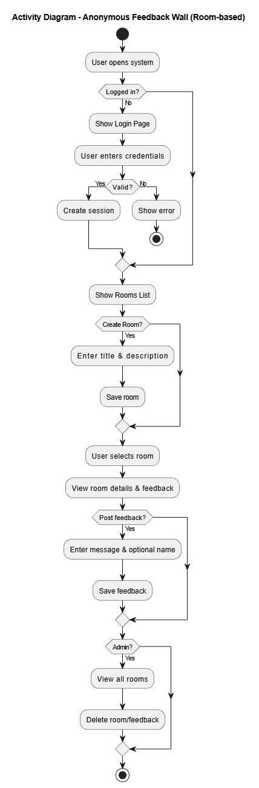
Fig 3.1 : System Flowchart
First, the system checks if the user is Already Registered; if so, they must provide Valid credentials to access the Index page, otherwise, they are redirected to the Log in page. From the Index page, if Feedback is submitted, the user is Redirected to wall page; if not, they remain on the Index page before reaching the Wall page. Finally, clicking Log out terminates the session and returns the user to the Log in page.

3.3.2 Workflow
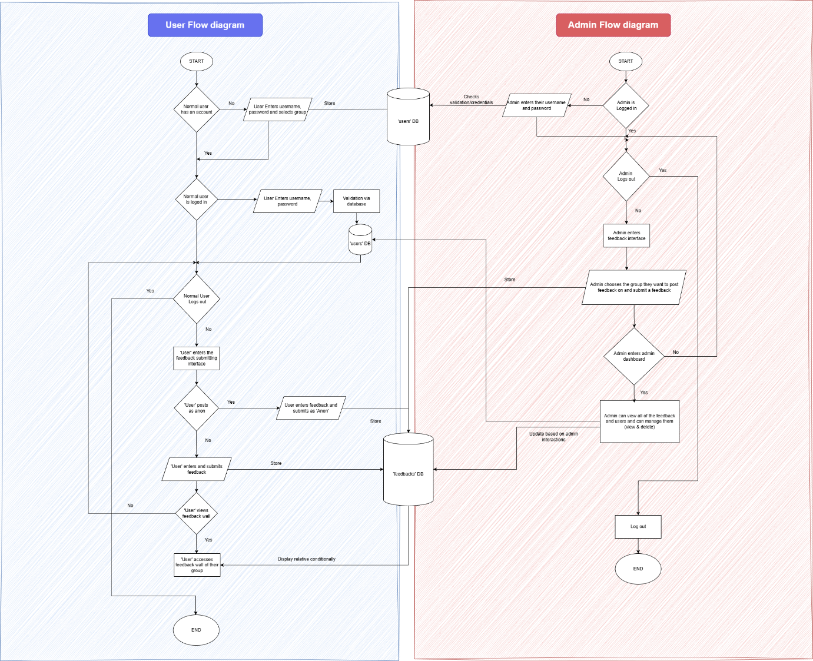
Figure 1: System Flowchart
Normal users can create an account, log in, submit feedback (anon or named), and view feedback for their group. Admins log in using their own credentials, post feedback to groups, and access the admin dashboard. Inside the dashboard, admins can view all feedback, update or delete messages, and manage group visibility. Both user and admin interactions update a shared feedback database that stores all submissions.

3.3.4 ER Diagram
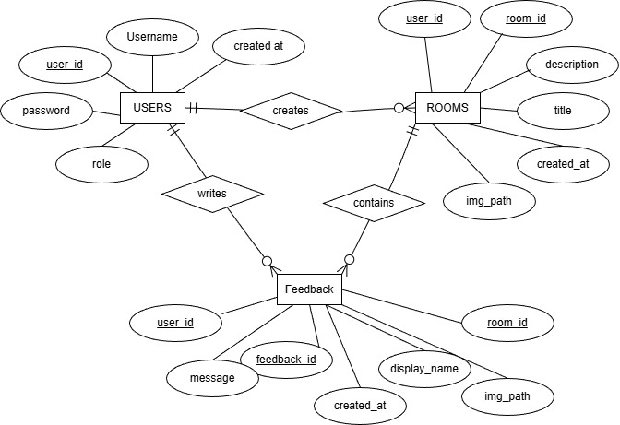
Figure 2: ER Diagram
The system stores users, feedback, and groups, linking them through defined relationships. Each user can submit many feedback posts, and each post belongs to one user and one group. Groups organize feedback visibility, where multiple feedback entries appear within a single group. Attributes like username, role, message, display name, and timestamps describe each entity in detail.

3.3.5 Use Case Diagram
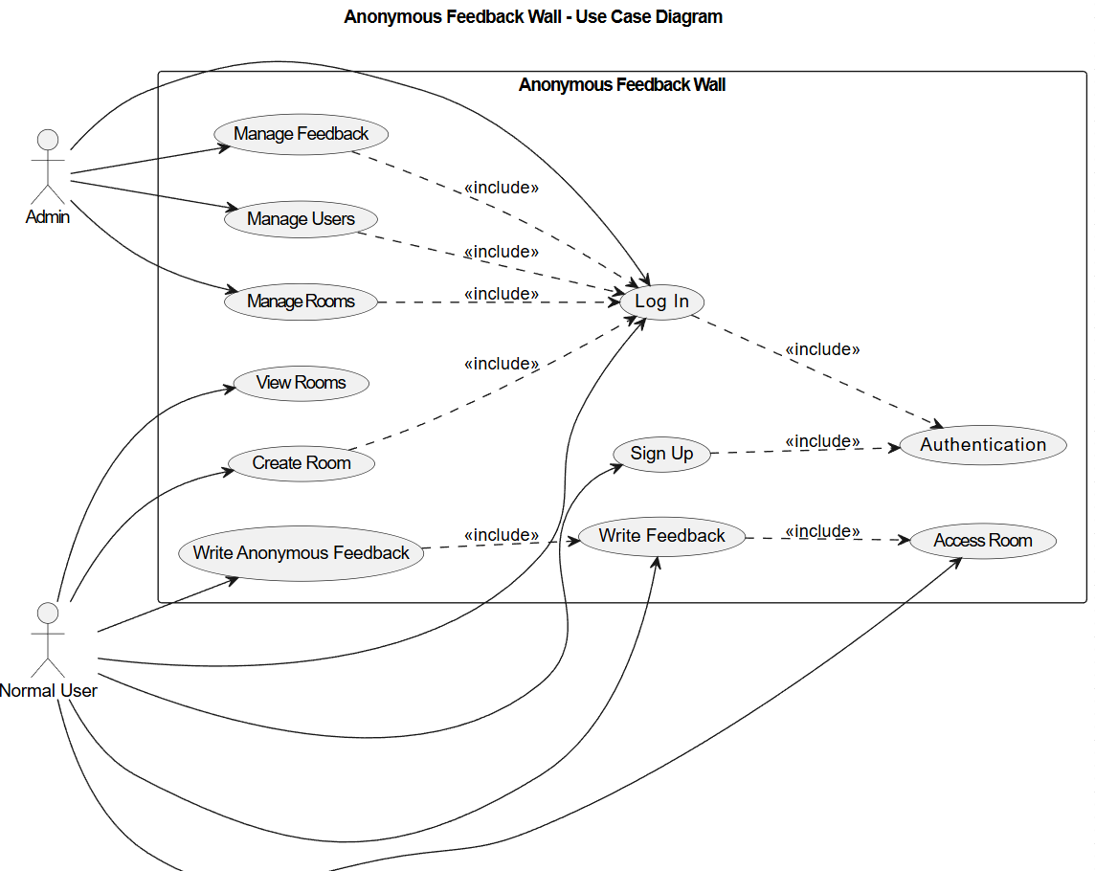
Figure 3: Use case diagram
This diagram shows how users interact with the Anonymous Feedback Wall system. Normal users can sign up, log in, write feedback, and view the feedback wall. Admins log in to manage feedback and manage users. Authentication is a required included process for all protected actions.

3.3.6 Sequence diagrams
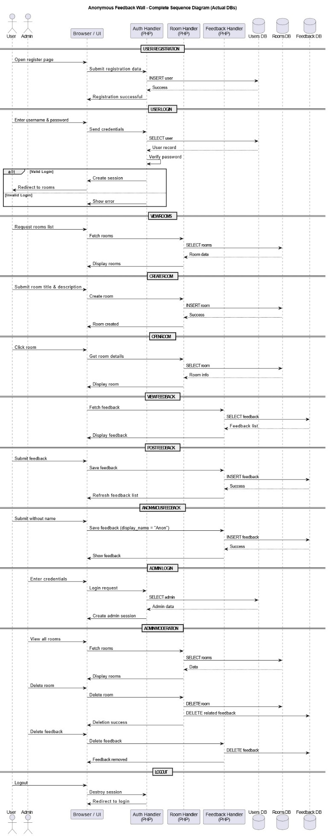

Figure 4: Sequence diagram
1. User Registration Sequence: The user opens the registration page and submits their details. The system stores the user information in the Users database and confirms successful registration.
2. User Login Sequence: The user enters login credentials. The system verifies the credentials using the Users database and creates a session if valid; otherwise, an error message is shown.
3. View Rooms Sequence: After login, the user requests the list of rooms. The system retrieves room data from the Rooms database and displays it to the user.
4. Create Room Sequence: The user submits a room title and description. The system saves the room details in the Rooms database and confirms room creation.
5. Open Room Sequence: The user selects a room. The system fetches the room details from the Rooms database and displays the selected room.
6. View Feedback Sequence: When a room is opened, the system retrieves all feedback related to that room from the Feedback database and displays it.
7. Logout Sequence: The user or admin logs out. The system destroys the session and redirects the user to the login page.

3.3.7 Database Schema Diagram
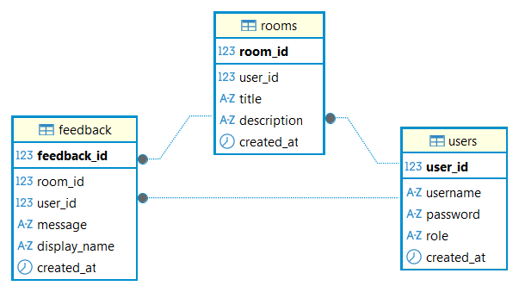
Figure 5: Database Schema
Technically, the diagram uses specific icons to denote Data Types and Primary Keys. Bolded fields like user_id, room_id, and feedback_id are unique identifiers that ensure no two records are identical. The icons indicate whether a field is a number (123), a string of text (A-Z), or a timestamp (clock icon). This structure ensures data integrity, making it easy to track exactly who posted what message and in which room it was shared.
The feedback table consists of feedback_id as primary key, room_id and user_id as foreign keys. Message, display_name and created_at are some data that this table handles and shows.
The room table consists of room_id as primary key and user_id as foreign key. Each room consists of a title and description, and also the date/time it was created in.
The users table consists of user_id as primary key. Each user has a username, password, role and when this user was created.

3.3.8 Data Flow diagram

DFD 0
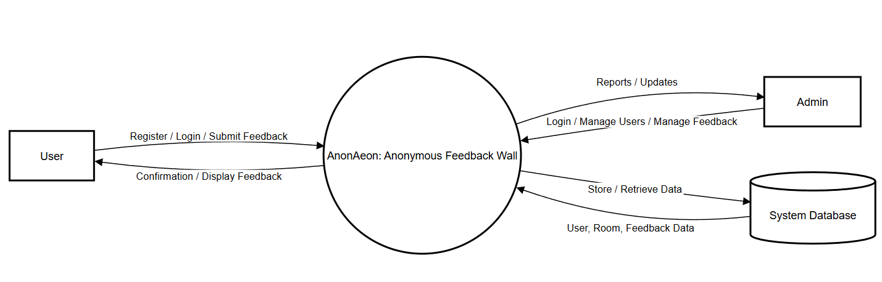
Figure 6: DFD Level 0

DFD 1
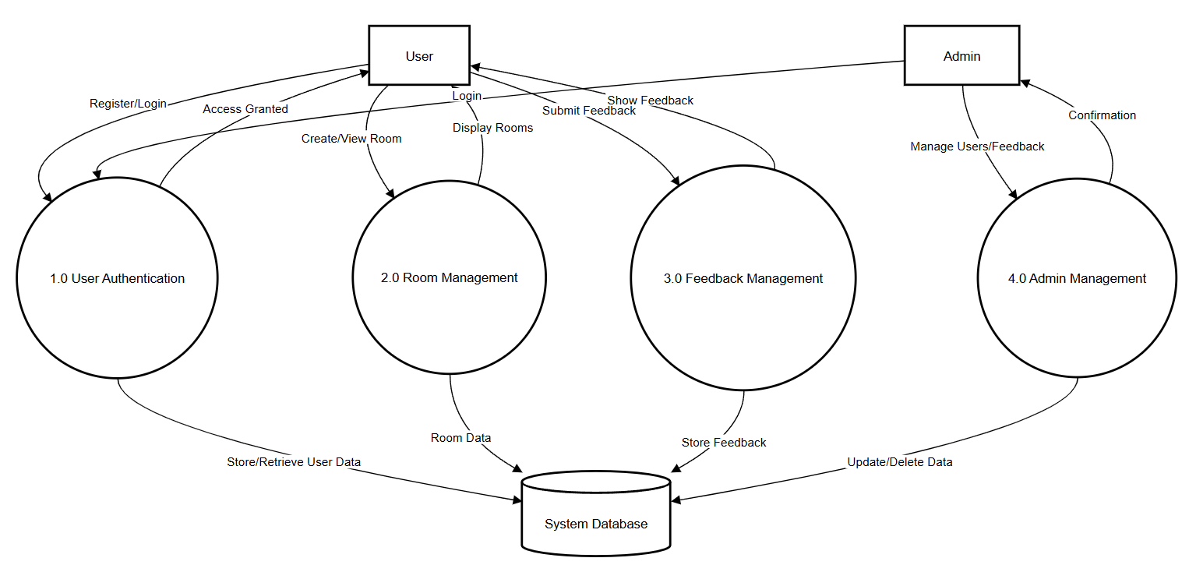
Figure 7: DFD Level 1

DFD 2
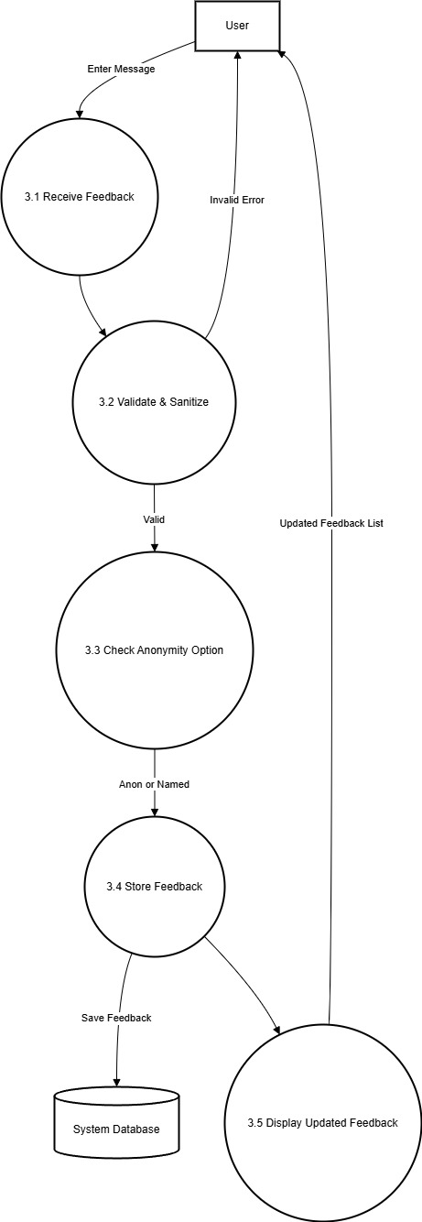
Figure 8: DFD Level 2
DFD Level 0
DFD Level 0 shows the entire AnonAeon: Anonymous Feedback Wall system as one main process interacting with external entities, namely the User and the Admin. Users can register, log in, create rooms, and submit anonymous feedback, while admins manage users and feedback through the system. All data is stored and retrieved from a central database, providing a high-level overview of how information flows between the entities and the system.
DFD Level 1
DFD Level 1 breaks the system into major modules such as User Authentication, Room Management, Feedback Management, and Admin Management. Each module handles specific responsibilities, like verifying users, managing rooms, processing feedback, and controlling administrative actions. These processes interact with the database to store and retrieve data, giving a clearer view of the internal structure of the system.
DFD Level 2
It provides a detailed view of the Feedback Management process by showing how feedback is received, validated, checked for anonymity, stored in the database, and displayed to users. It explains the internal flow of data step-by-step within a single module. This level helps in understanding how feedback is processed before becoming visible in the system.

CHAPTER 4: SYSTEM IMPLEMENTATION

4.1 Project Schedule

4.1.1 Detailed Time Schedule
Table 1: Detailed Time Schedule
Task Id | Task Name | Start Date | End Date | Duration
1 | Preliminary Work
1.1 | Planning of the project | 11-Nov | 12-Nov | 2
1.2 | Analysis on the topics | 12-Nov | 14-Nov | 3
1.3 | Background reading | 14-Nov | 15-Nov | 2
1.4 | Preliminary research | 15-Nov | 15-Nov | 1
2 | Research Work
2.1 | Research on Feedbacks | 15-Nov | 17-Nov | 3
2.2 | Research on Rooms and Anonymity | 17-Nov | 19-Nov | 3
3 | Design and Development
3.1 | System Architecture Design | 20-Nov | 21-Nov | 2
3.2 | Context Diagram and DFD | 21-Nov | 21-Nov | 1
3.3 | Designing System Flowchart | 21-Nov | 21-Nov | 1
3.4 | Use Case Diagram | 22-Nov | 22-Nov | 1
3.5 | ER Diagram | 22-Nov | 22-Nov | 1
3.6 | Sequence Diagram | 22-Nov | 22-Nov | 1
3.7 | Schema of Database | 22-Nov | 22-Nov | 1
4 | Coding and Implementation
4.1 | Code Feedback System and Room Systems | 22-Nov | 26-Nov | 5
4.2 | Test Feedbacks and Rooms working | 26-Nov | 30-Nov | 5
4.3 | Code User Interface | 30-Nov | 5-Dec | 5
4.4 | Test system | 5-Dec | 30-Dec | 25
5 | Dissertation
5.1 | Critical Analysis | 31-Dec | 1-Jan | 2
5.2 | Draft Report Writing | 1-Jan | 3-Jan | 3
5.3 | Final Report Writing | 3-Jan | 10-Jan | 8
5.4 | Report Evaluation and Conclusion | 20-Feb | 22-Feb | 3
5.5 | Submission of draft copy report | 22-Feb | 22-Feb | 1
5.6 | Correction for final draft copy | 23-Feb | 25-Feb | 3
6 | Final Phase
6.1 | Final Documentation Printing and Binding | 26-Feb | 26-Feb | 1

4.1.2 Detailed Gantt Chart

Figure 9: Gantt Chart

4.2 Implementation
The Anonymous Feedback Wall system is a web-based application designed to allow users to create discussion rooms and provide feedback in an open and optionally anonymous manner. The overall architecture follows a modular approach, where each major functionality is handled by a separate module to ensure clarity, scalability, and ease of maintenance.

4.2.1 User Authentication Module
The user authentication module is responsible for handling user registration, login, and logout functionalities. New users can register by providing a unique username and password, which are securely stored in the Users database using password hashing techniques.

4.2.2 Room Management Module
The room management module allows authenticated users to create discussion rooms. Each room consists of a title and a description that defines the topic of discussion. When a user creates a room, the system stores the room details along with the creator’s user ID in the Rooms database.

4.2.3 Room Viewing Module
The room viewing module enables users to select and open a specific room. When a room is accessed, the system retrieves the room’s details from the Rooms database and displays them along with the associated feedback. This module ensures that users can easily navigate between rooms and understand the context before submitting feedback.

4.2.4 Feedback Submission Module
The feedback submission module allows users to post feedback within a selected room. Users can choose to submit feedback anonymously or provide a display name. If no name is provided, the system automatically assigns the default name “Anon.” Each feedback entry is stored in the Feedback database with references to the corresponding room and user.

4.2.5 Feedback Display Module
The feedback display module retrieves and presents all feedback related to a specific room. Feedback entries are displayed in chronological or reverse-chronological order, along with the display name and submission timestamp. This module ensures real-time interaction within rooms and provides a clear discussion flow.

4.2.6 Admin Management Module
The admin management module provides additional privileges to administrators. Admin users can view all rooms and feedback entries across the system. They have the authority to delete inappropriate rooms or feedback to maintain platform integrity. Although implemented using the same database tables as normal users, admin actions are controlled through role-based access checks to prevent unauthorized operations.

4.2.7 Database Implementation Module
The database integration module manages all interactions with the MySQL database, including user records, room data, and feedback entries. Prepared statements are used throughout the application to prevent SQL injection attacks. The database structure is kept minimal and efficient, consisting only of Users, Rooms, and Feedback tables, ensuring simplicity and performance.

4.3 Result

4.3.1 Screenshots
- Sign up page:
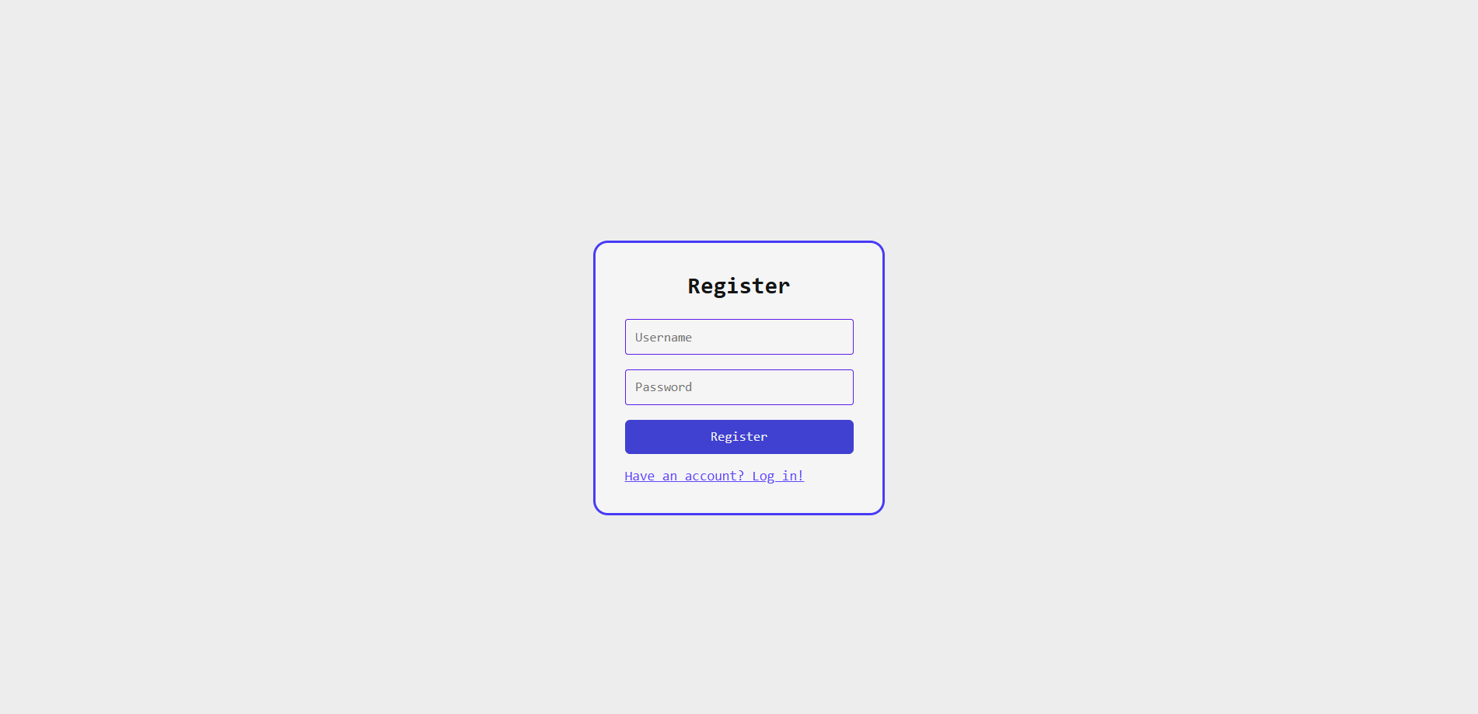
Figure 10: Register Page
User registration form, this is the page where user registers. The registered data of the user is stored in the database with password being hashed. After registering, the user is redirected to the log in page.
- Log in page: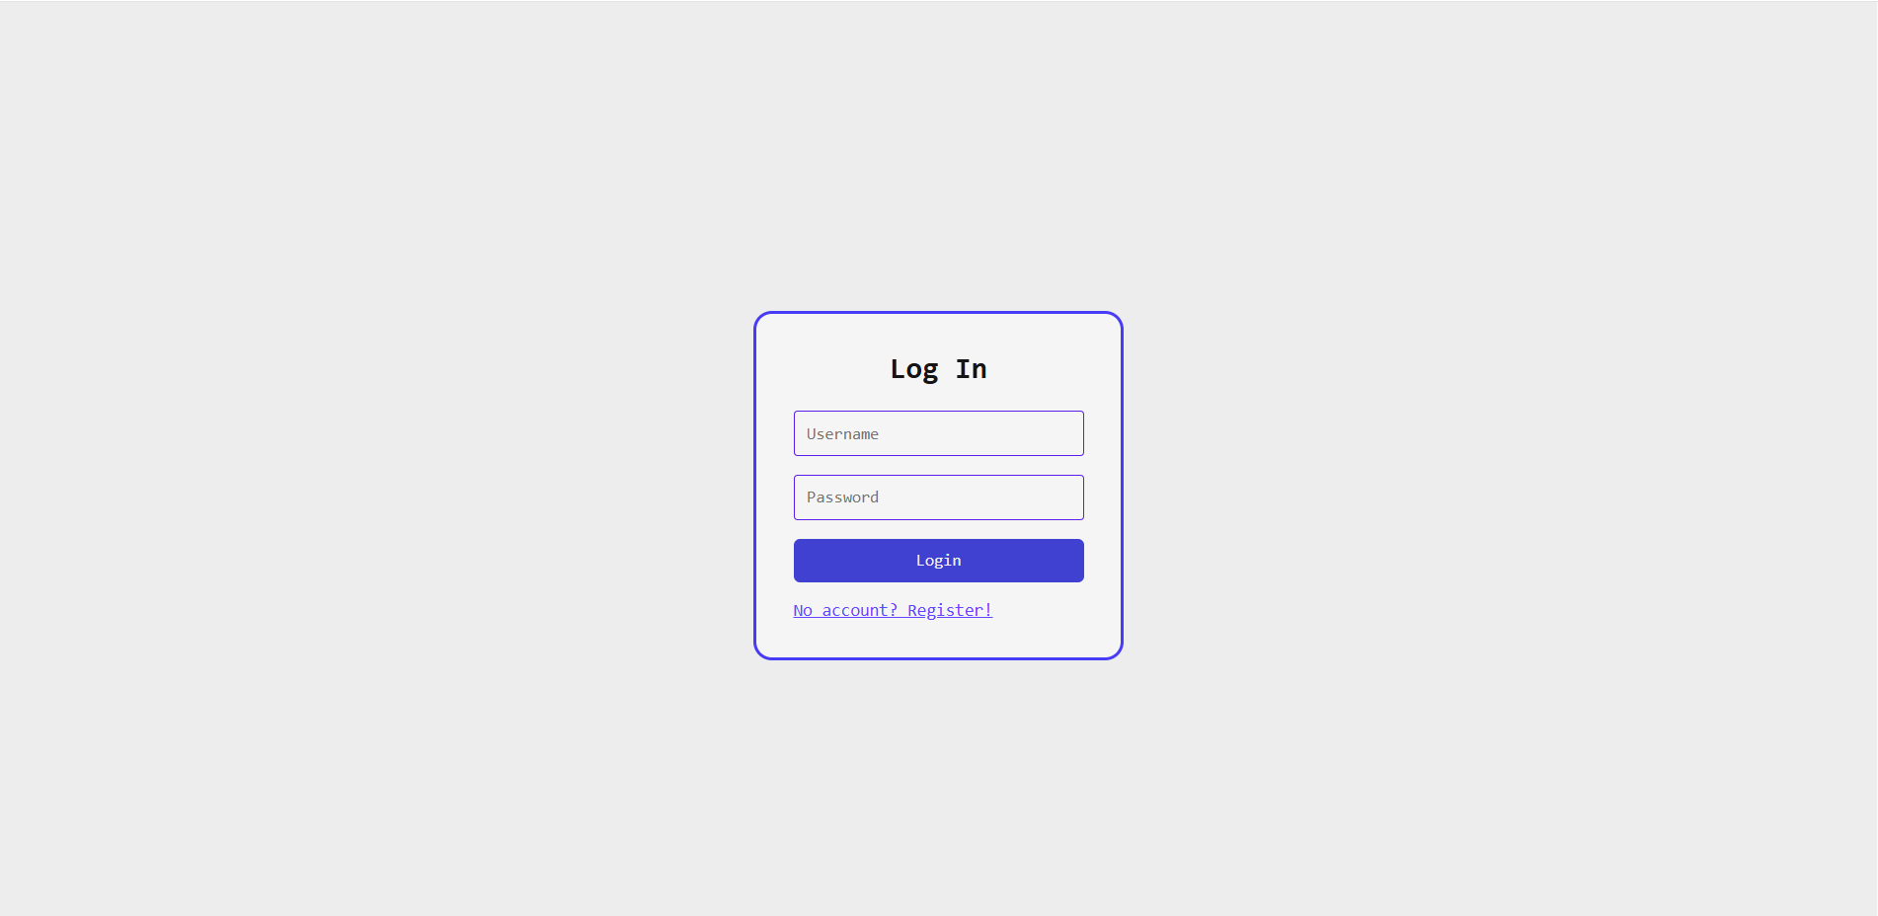
Figure 11: Log In page
This is where the user is redirected after signing up, this is where user can enter their username and password for authentication which is authorized whether a normal user or an admin logged in and is redirected to their respective pages
- Rooms page: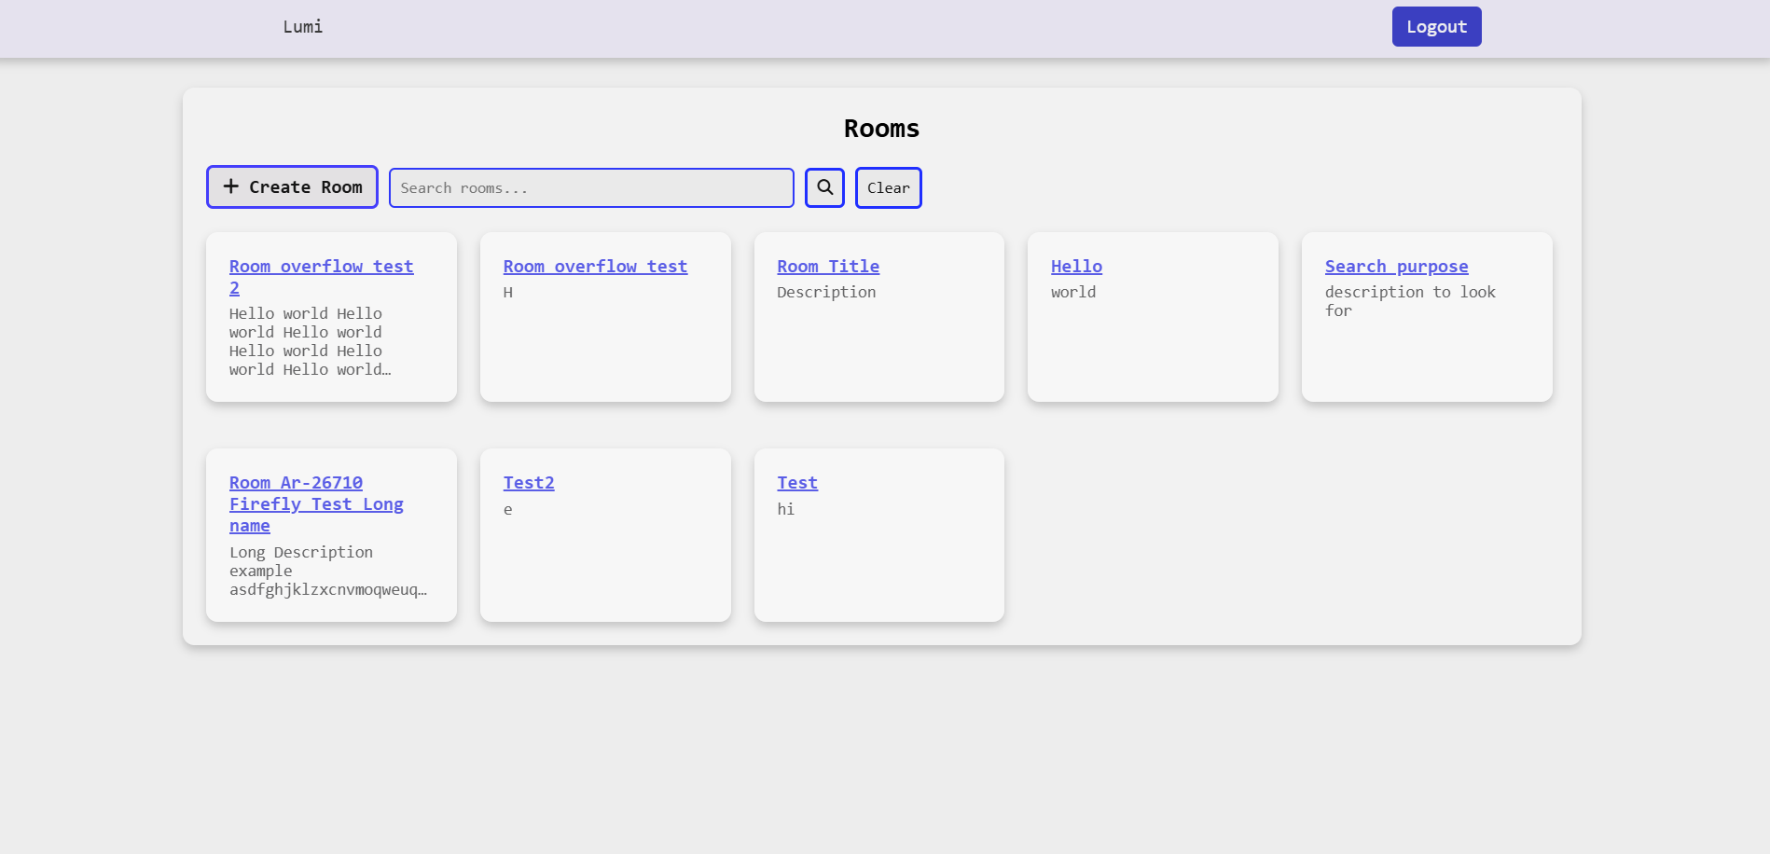
Figure 12: Room View page
The above page shows rooms page, this is where users can view all available rooms of feedbacks, and also search among them based on room title and description. They can also create their own room by clicking on “+ Create Room” which they will be redirected to create room page
- Create rooms page: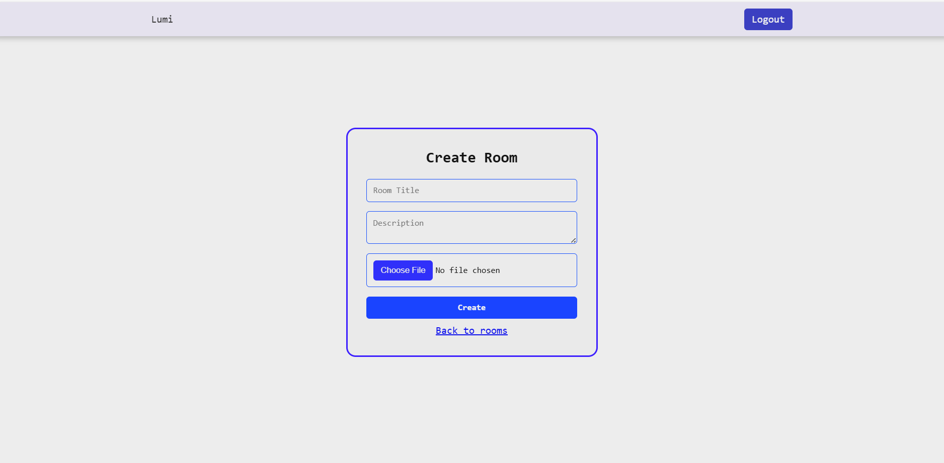
Figure 13: Create Room Page
The above page shows the create room page after the user clicks on “+ Create Room” on the rooms page. Here, the user can create a new room based on the feedback they need on. They can enter Room title and description and image(Not functional at the moment).
- Room page: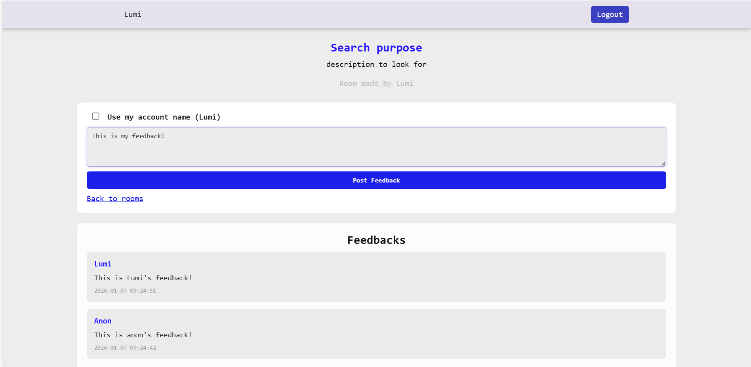
Figure 14: Room page
The above page shows the result after clicking on one of the rooms in the rooms page. It is a room where a user can see room’s title, description and author on top. They can post user feedback on the text-area. The submitted result is displayed below in the “Feedbacks” section.

4.4 Critical Analysis
The overall system performance of AnonAeon: Anonymous Feedback Wall is stable and efficient for small to medium-scale environments such as colleges or organizations. The use of PHP and MySQL ensures reliable server-side processing and structured data storage, while HTML, CSS, and JavaScript provide a responsive and user-friendly interface. The system performs core operations such as user authentication, room creation, feedback submission, and administrative management within acceptable response times under normal load conditions. Data validation mechanisms enhance system reliability by preventing incomplete or invalid submissions, and centralized database management ensures organized data retrieval and storage.
Despite its functional effectiveness, the system has certain limitations. The platform currently relies on basic moderation features, which may not fully prevent spam, inappropriate content, or repeated misuse in large-scale deployments. Scalability could also become a concern if the number of users and feedback submissions increases significantly, as performance optimization mechanisms such as caching or load balancing have not been implemented. Additionally, the system lacks advanced analytical tools for processing feedback trends, sentiment analysis, or automated categorization, which limits deeper insight extraction from collected data. Security measures, while adequate for academic purposes, could be further strengthened through encryption enhancements and multi-factor authentication.
Future improvements can significantly enhance the system’s effectiveness and sustainability. Implementing automated content filtering and AI-based sentiment analysis would improve feedback quality and analytical value. Introducing role-based access control and stronger encryption methods would enhance security and privacy protection. Performance optimization techniques such as database indexing, query optimization, and scalable hosting solutions could support larger user bases. Furthermore, integrating reporting dashboards with visual analytics would provide administrators with actionable insights for decision-making. With these enhancements, the system could evolve from a basic feedback collection tool into a comprehensive feedback management platform suitable for broader institutional and organizational use.

Chapter 5: Conclusion and Future Enhancements

5.1 Conclusion
The AnonAeon: Anonymous Feedback Wall project successfully demonstrates the design and implementation of a secure web-based platform for collecting and managing anonymous feedback. By integrating PHP, HTML, CSS, JavaScript, and MySQL, the system provides a structured environment where users can freely share their opinions while administrators can efficiently monitor and manage submissions. The project highlights the importance of transparency, accessibility, and proper data handling in modern feedback systems.
Overall, the system addresses communication gaps within educational and organizational settings by encouraging honest participation and continuous improvement. Although certain enhancements such as advanced analytics and scalability features can be added in the future, the current implementation effectively meets its objectives and serves as a practical solution for real-time anonymous feedback management.

5.2 Future Enhancements
The system can be enhanced by integrating advanced analytical features such as sentiment analysis, keyword extraction, and automated feedback categorization to help administrators better understand trends and patterns. Implementing graphical dashboards with data visualization tools would allow easier interpretation of feedback statistics. Additionally, adding email notifications or real-time alerts could improve responsiveness when new feedback is submitted.
From a technical perspective, future improvements may include implementing stronger security measures such as end-to-end encryption, multi-factor authentication, and role-based access control. Scalability can be improved through optimized database indexing, cloud hosting, and performance tuning for handling larger user bases. Furthermore, developing a mobile-responsive enhancement or a dedicated mobile application would increase accessibility and usability across different devices.

References
[1] Joshi, S., Kasaju, B., Karki, P., Aryal, S. K., & Chhetri, S. B. (2022, October). Smart canteen management system. In 2022 IEEE 2nd Mysore Sub Section International Conference (MysuruCon) (pp. 1-5). IEEE.
[2] Toma, S. T. F., Karmaker, D., Iqbal, S., Pantho, M. H. K., & Antara, R. S. I. (2021, December). Canteen Automation System: An Approach for “Smart City” Planning. In 2021 IEEE Asia-Pacific Conference on Computer Science and Data Engineering (CSDE) (pp. 1-6). IEEE.
[3] Narendran, A., Inuguri, A. H., Yashaswini, M., Sundaram, S., & Khanna, M. (2024, November). A Next-Gen Approach to Streamlined Canteen Management Systems using Mesa Framework. In 2024 8th International Conference on Computational System and Information Technology for Sustainable Solutions (CSITSS) (pp. 1-5). IEEE

